ELECTRICAL DESIGN JUSTIFICATION: - FC1
-by Kushagra Srivastava

Full Schematic: -
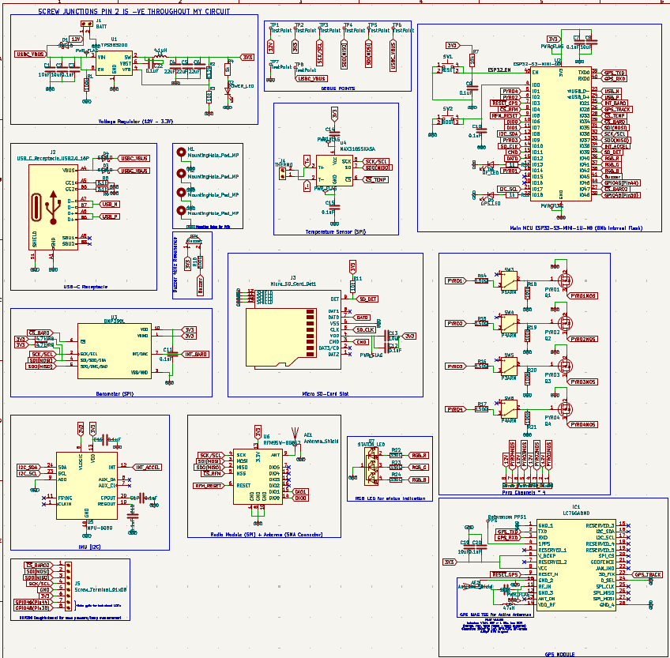
- TPS563200 (12v - 3.3v): - 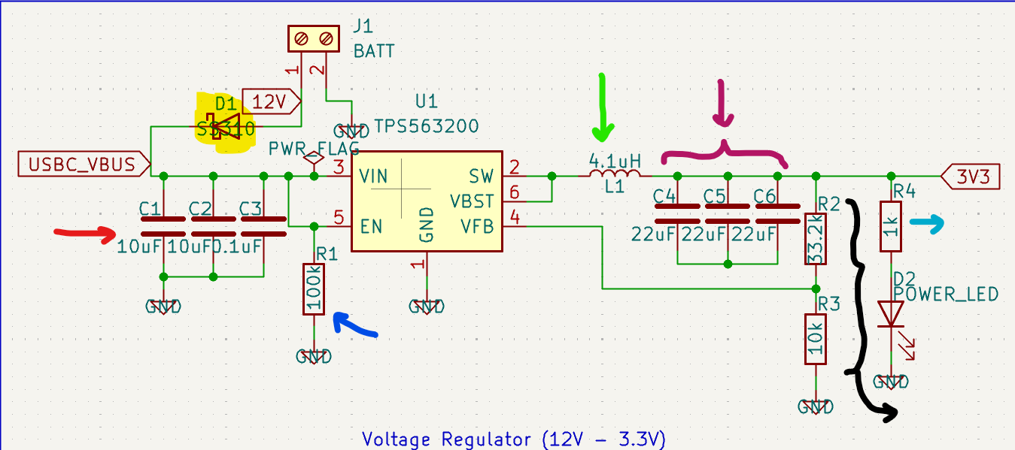

Yellow Highlighter: - SS310 FLYBACK DIODE Why SS310? -> very high surge current capability (100A), high DC blocking/reverse voltage rating (VDC = 100v), providing sufficient margin against inductive voltage spikes, Max. instantaneous forward voltage at max load (3A) = 0.85 (enables fast and efficient flyback clamping) + Max DC reverse current at 25 degree Celsius = 0.6mA; at 100 degree Celsius = 20mA.

Red Arrow: - Input Decoupling Capacitors Switching frequency for tps563200 is 650kHz (datasheet), resulting in pulsed input current drawn from the supply, 2 * 10uF ceramic caps (0603 1608 metric) are placed close to the Vin pin to supply clean current and limit input voltage droop

T = 1/f
F = 650kHz
T = ~1.54 micro seconds => switching period
assuming a conservative 0.5 micro second switching period for voltage droop calc.

Input Current: - Vout = 3.3V
(IOut)Peak = 0.45A (conservative estimate)(actual draw ~0.3A)
Power = I * V
(3.3) * (0.45) = 1.485W ~ 1.5W (power delivery)
Input current for 12V => P / V = I
1.5W / 12V = 0.125A
From Schematic: - 2 * 10uF caps at input – 20uF effective (Acts as bulk caps)
ΔVin = [((I)in) * Δt] / C ------> voltage droop
ΔVin = ( 0.125 * 0.5 * 10^-6 ) / 20 * 10^-6
ΔVin = 0.003125V
ΔVin = 3.125mV ------> Very little voltage droop observed

0.1uF Cap is still used for HF decoupling as bulk caps become ineffective at suppressing switching edge harmonics due to ESL. Ensures low impedance at HF and reduces EMI.
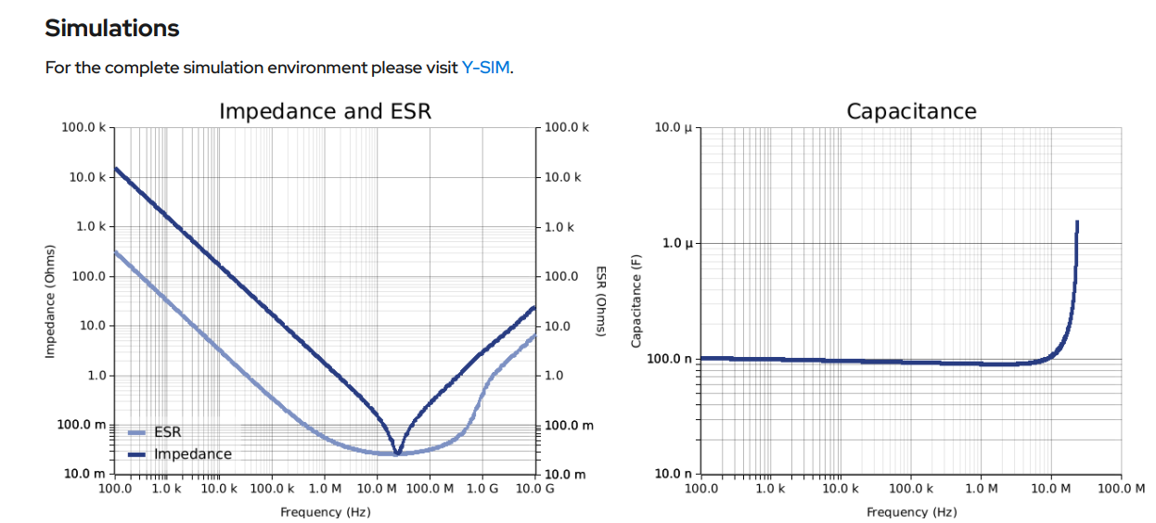
Input capacitance is very close to 0.1uF for the 0.1uF cap at 650kHz switching frequency for the chosen 0.1uF cap (refer graph 2)

Dark Blue Arrow: - Enable pin pulldown when power is not provided. This is added to GUARANTEE a defined OFF state during power ramp up, hotplugging usb, brownouts/battery reconnect and not have any floating EN conditions.
Common failure mode without pulldown: - During powerup transients, ViN starts rising, EN floats through EMI and regulator partially enables, outputting random currents or undesired voltage outputs…the MCU may brownout or may not latch correctly.

- Enable pin of the TPS563200 is driven by the main loop because I wanted for the board to function independently without the need of a full size 12v battery, and I wanted it to be able to function with just the USB-C VBUS 5v laptop USB Power supply, earlier revisions had a faulty enable pin circuitry, where the voltage regulator would only be enabled when the USBC receptacle was receiving power, even if the main battery would be connected, the voltage regulator wouldn’t function.

Green Arrow: - Inductor for stabilizing Transients SRP3212A-4R7M Inductor chosen 1210 (3225 metric).
Chosen Inductor value: - 4.7uH (Closest Alternative to 4.1uH available)
(Why 4.7uH even though the calculated value was 4.163uH? => because we need the regulator out of deep DCM at real operating currents, not idealistic numbers, in real life, inductors have a 20% tolerance, meaning the inductor current could become -ve, resulting in higher peak currents, noisier 3.3v output, worse EMI, and could reduce overall efficiency, 4.7uH keeps the DCM shallow at light load and CCM at higher loads when pyros are fired or RF transmission peaks occur. Higher L lowers Output ripple and reduces RMS current in output caps.)
Target Ripple: - 30% of max load (0.45A according to power budgetary) = 0.135A
Inductor (peak to peak) ripple current = 0.797A
Inductor saturation current = 0.8485A
Inductor RMS current = 0.5054A
Output Decoupling caps Current rating = 0.230A
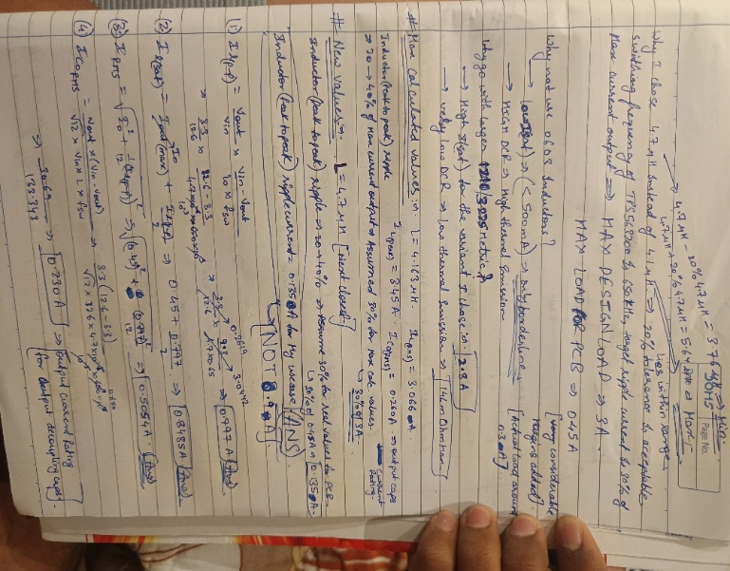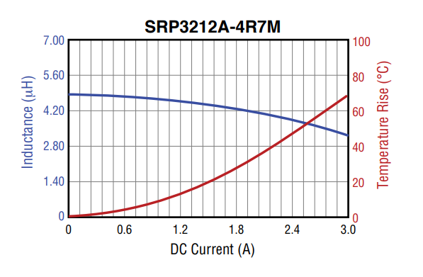

ΔIL(p-p) = 0.78A; Iout = 0.45A; minimum inductor current: -
ILmin = Iout – (ΔIl/2) = 0.45 – 0.39 = 0.06A.
CCM is observed at the peak current load assumption…
But for 0.3A Load (Real case): -
ILmin = 0.30 – 0.39 = -0.09A
Negative current means inductor current hits zero and DCM is observed…but DCM is supported by TPS563200 at light loads like 0.3-0.5A, and -0.09A means we do not enter a deep DCM state, we cross the boundary only slightly so it can be considered as Boundary conduction mode (BCM). TPS563200 is stable in Both DCM and CCM. At lower values of inductance, we observed deep DCM, which is not desirable, 4.7uH Keeps DCM shallow and controlled.
0603 inductors are not enough for switch mode power supply output filters due to limited saturation and RMS current ratings(<500mA Isat, HIGH DCR). For TPS563200, I chose a shielded power inductor with 2.8A saturation current And Irms = 2.2A and low DCR (146mOhm) to prevent current saturation, ensure stable inductance under load, and minimize EMI and thermal stress. 1210 (3225 metric) size inductor. Saturation margin: >3×
RMS margin: >4×
Summary: • Max load: 0.45A @ 3.3V
• Mode: BCM at light load, CCM at peak
• Inductor: 4.7µH, Isat 2.8A, Irms 2.2A
• Output ripple < spec, stable in DCM/CCM

Magenta Brackets: - Output decoupling capacitors (LMK107BBJ226MA) 0603 Caps chosen
Why? => Output caps RMS current = 0.23A
For The chosen 22uF 0603 MLCC Cap: -
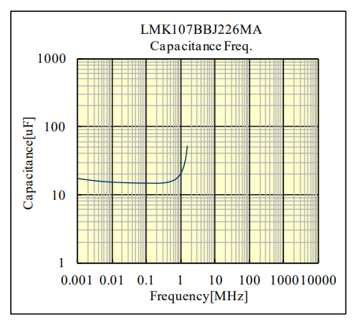
The effective capacitance is 12-15uF per capacitor at 650kHz (tps563200 switching frequency)
With 3 caps In parallel – we get around 36 - 45uF effective capacitance.
Total cap ripple is 0.23A RMS current… with 3 caps in parallel, we get ~ 78 mA per capacitor… 0603 MLCC’s can handle 200-300mA RMS current very easily, hence 0603 good enough for output decoupling caps
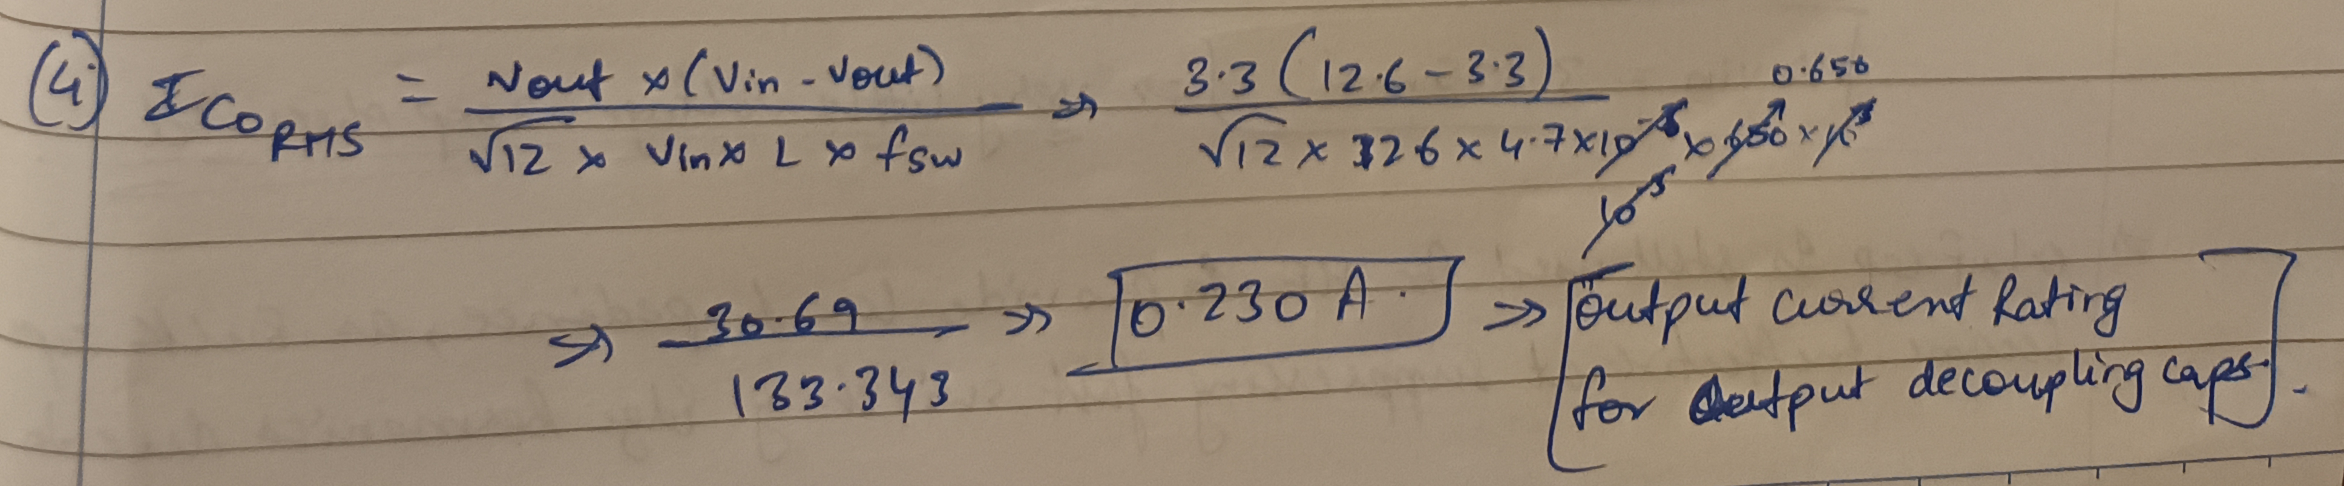

Voltage divider Apparatus for VFB: - Recommended values by the datasheet for proper 3.3v output, I calculated the value myself(assuming R2 (bottom resistor) to be 10k and calculating R1(top resistor)) and my value was within 0.1% of the recommended values, so the datasheet values are verified.
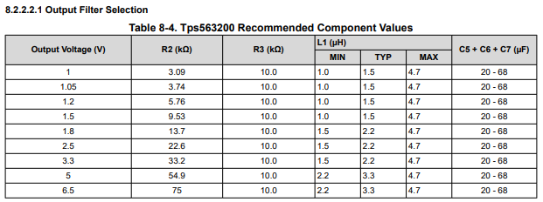
Light Blue Arrow: - ( LTST-S270KRKT Vf = 2V ESD PROTECTION NEEDED)1k Resistor for (white color) LED for Power supply Indication, will be used for debugging in case of unaccounted failures.
LED rated for 20mA (3-5mA conservative, long life; 6-8mA brighter still safe; >= 10mA unnecessary for our requirements; Target current should be around 5-7mA), We need power indicator to be bright to confirm power status, and because it is connected directly to the 3.3v supply, it needs to work for hours at a time without wear and tear.
Vr = (3.3 - 2) = 1.3v (Voltage across resistor)
I = 1.3v/220 = 0.005909A ~ 6mA current goes into the LED
R = (3.3 – 2) / 5 * 10^-3
R = 280Ω
nearest standard value = 270Ohm
(Not 1k as shown in the schematic, the value was updated after calculations)
Efficiency Curves: -
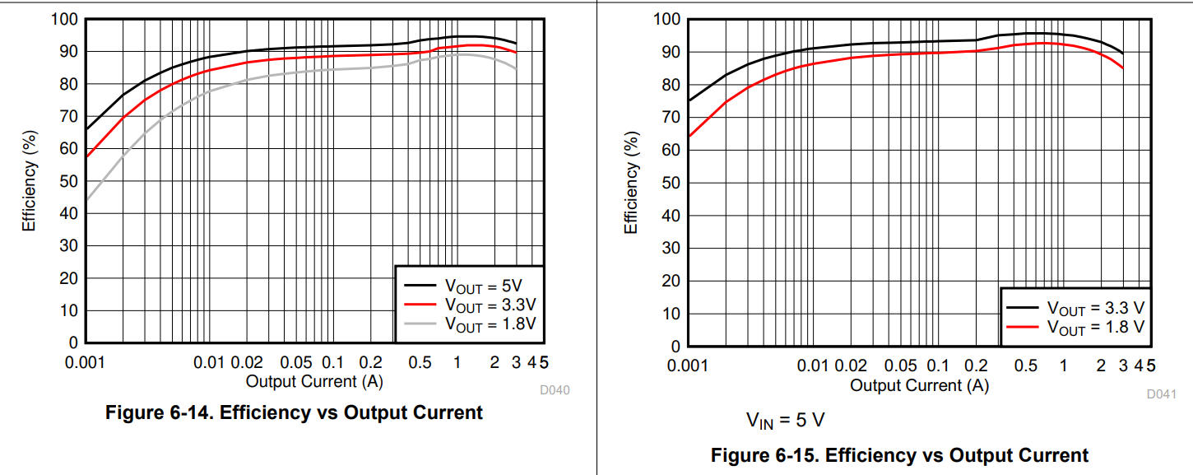 Graph 1 => vin = 12v (BATTERY) ; Graph 2 => vin = 5v (USBC_VBUS)
Extremely high efficiency (90-93%) compared to the previous iterations where I used LD11173V3 and LM2596, (Around 66% efficiency total for 12-5v using LM2596 Buck then 5 to 3.3v using LD11173V3)

LED (common cathode) RGB for state indication: - XZM2CRKM2DGFBB45SCCB Digikey Ref.
Red: - Vf = 2v
Target current = 5mA
R = (3.3 – 2) / 0.005 = 1.3 / 0.005 = 260Ω
Nearest standard value = 270Ω
Green: - Vf = 3v
Target current = 3-4mA
Trying 100 Ω: - I = (3.3 – 3) / 100 = 3mA
(Extremes: - Vf = 2.8v 5mA
Vf = 3.1v 2mA)
Blue: - Vf = 3.1v
With 100 Ω :- I = (3.3 – 3.1) / 100 = 2mA
Blue should be visible even at low currents
LED’s used for status indication: -
Function | LED Color | Resistor | Current(Typ.) | Digikey ref.
Power | RED (Vf = 2v) | 270 Ω | ~5mA | LTST-S270KRKT
RF Lock | WHITE (Vf = 2.8v) | 100 Ω | ~5mA | IN-S63AT5UW
GPS Lock | WHITE (Vf = 2.8v | 100 Ω | ~5mA | IN-S63AT5UW
RGB LED (STATUS) | RGB | R = 270 Ω  B = 100 Ω  G = 100 Ω | R = 5mA  B = 2mA  G = 3mA | XZM2CRKM2DGFBB45SCCB
ITotal = (5 + 5 + 5 + 5 + 2 + 3)mA = 25mA for all leds combined
- ESP32 - S3 – Mini – 1 – U: - (N8 variants with 8MB Integrated Flash)
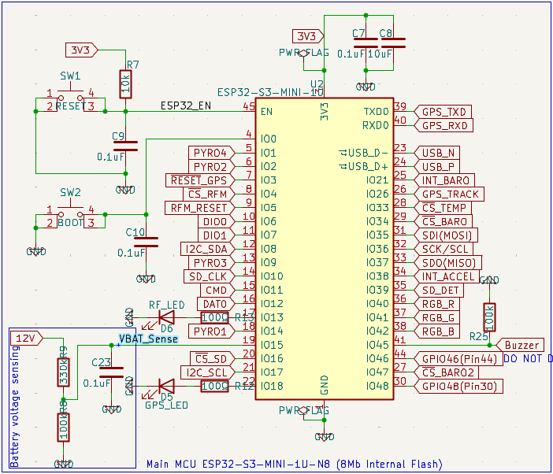
PINOUTS FOR ESP32: -
Pin 1 GND GND
Pin 3 3V3 3.3v Supply after 2 decoupling caps (0.1uF for HF noise and 10uF for bulk decoupling)
Pin 45 EN Reset Tactile Switch (Pulled high (3.3v) using a 10k Resistor, and 0.1uF to GND)
Pin 4 IO0 Boot Tactile Switch (Pulled low(GND) using a 0.1uF cap)
Pin 5 IO1 PYRO 4
Pin 6 IO2 PYRO 2
Pin 7 IO3 GPS Reset Line
Pin 8 IO4 RF Module Chip Select
Pin 9 IO5 RF Module Reset Line
Pin 10 IO6 DIO0 RF Module
Pin 11 IO7 DIO1 RF Module
Pin 12 IO8 I2C SDA Line (IMU Runs on I2C)
Pin 13 IO9 PYRO 3
Pin 14 IO10 CLK Line for MicroSD Card Slot
Pin 15 IO11 CMD Line for MicroSD Card Slot
Pin 16 IO12 DAT0 Line for MicroSD Card Slot
Pin 17 IO13 RF LOCK Indication LED
Pin 18 IO14 PYRO 1
Pin 19 IO15 VBAT_Sense for battery voltage sensing using inbuilt ADC
Pin 20 IO16 MicroSD Card Slot Chip Select (Pulled HIGH (3.3v) using 4.7k Resistor as it is an active LOW CS Pin)
Pin 21 IO17 I2C SCL Line (IMU Runs on I2C)
Pin 22 IO18 GPS LOCK Indication LED (GPS Module has a GPS LOCK Indication pin…when it is driven HIGH, we can add one line of code enabling IO18 to indicate GPS lock on an LED)
Pin 39 TXD0 GPS TXD (GPS runs on UART)
Pin 40 RXD0 GPS RXD (GPS runs on UART)
Pin 23 USBD- USB_N Line
Pin 24 USBD+ USB_P Line
Pin 25 IO21 Interrupt Pin for Onboard Barometer
Pin 26 IO26 GPS TRACK pin
Pin 28 IO33 Temperature Sensor Chip Select
Pin 29 IO34 Onboard Barometer Chip select
Pin 31 IO35 SDI (MOSI) (SPI Common Lines)
Pin 32 IO36 SCK/SCL (SPI Common Lines)
Pin 33 IO37 SDO (MISO) (SPI Common Lines)
Pin 34 IO38 Interrupt Pin for IMU
Pin 35 IO39 SD Detection Pin
Pin 36 IO40 RGB RED (Status Indication, Pyro Armed(Blue), Safe(Green), Unsafe(RED))
Pin 37 IO41 RGB GREEN (Status Indication, Pyro Armed(Blue), Safe(Green), Unsafe(RED))
Pin 38 IO42 RGB BLUE(Status Indication, Pyro Armed(Blue), Safe(Green), Unsafe(RED))
Pin 41 IO45 Passive Piezo Buzzer with 100k Pulldown (Pin41 GPIO45 is a Strapping pin, pulling it HIGH can lead to erratic behavior of ESP32 During resets or boot, No Data was available for Cui – Cpt 9019S Buzzer if it works on pulling the pin high or low during resets…100k Pulldown ensures even if the buzzer pulls high no erratic behavior is observed)
Pin 44 IO46 Screw Junction Output for Future expansion (Eg: - Test Stand LED operation)
Pin 27 IO47 External Barometer Chip Select (Nose cone barometer For temp and Pressure measurement)
Pin 30 IO48 Screw junction Output for Future expansion (Eg: - Test Stand LED operation)

BMP288 Daughterboard For Nose Cone Pressure And Temp Measurement: -
Expansion Screw junctions are available on the topside of the Flight computer for a BMP288, which will run on SPI (Pins 8 1 goes from Left to Right)
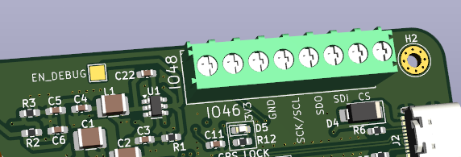
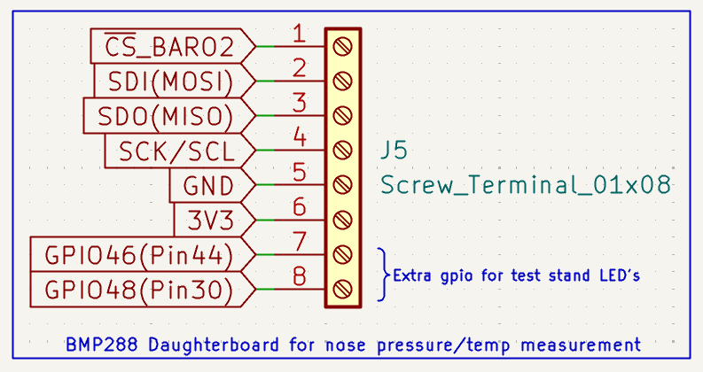
Pin 8 GPIO48 (Pin30) Extra GPIO for test stand LED’s
Pin 7 GPIO46 (Pin44) Extra GPIO for test stand LED’s
Pin 6 3V3
Pin 5 GND
Pin 4 SCK/SCL
Pin 3 SDO (MISO)
Pin 2 SDI (MOSI)
Pin 1 External Barometer Chip Select
All ESP32 Strapping pins (GPIO 0, 45, 46) Are held in safe states during resets by external precaution (GPIO46), or Pulldown resistors (GPIO0, 45).
- ESP32 3V3 Input decoupling: - 0.1uF for HF Decoupling, 10uF for Bulk Decoupling,
ΔV = (I * Δt)/C
Assuming a modest internal Event: -
I = 50mA
Δt = 2ns
C = 0.1uF
ΔV = (0.05 * 2 * 10^-9) / 1 * 10^-7 = 1mV
Good enough if the cap is close enough….

Inductance Penalty from Decoupling caps placed 3.5mm from the 3V3 Pin : -
L ~ 1nH / mm L ~ 3.5nH
Voltage dip due to Inductance: - E = L * dI/dt
Assuming ΔI = 150mA
Δt ~ 5ns
E = L * dI/dt = 2.6 * 10^-9 * (0.15 / 5 * 10^-9) ~ 78mV
We get 70-80mV droop…well within esp32 limits for brownouts

- Resistances for GPS and RF lock LED’s: - (WHITE LEDS (IN-S63AT5UW) WITH FORWARD VOLTAGE 2.8V)
- Resistance Value chosen: - 100 Ohm
Assuning Vgpio = 3.3v
Vf = 2.8v
Inominal = (3.3 - 2.8) / 100 = 0.5 / 100 = 5mA
5mA is the optimal setup
Worst case scenario: -
Vf = 2.6v (assuming led gets hot)
Vgpio = 3.3v
Iworst = (3.3 - 2.6) / 100 = 0.7/100 = 7mA
7mA is the worst case scenario
ESP32 GPIO’s can handle upto 40mA but are rated for around 12mA continuous operation, our worst case scenario is well under the required limits.

- Battery Voltage Sensing (voltage divider + RC low pass filter): -
Chosen resistances Rtop = 330k
Rbottom = 100k
VADC (max) = 12.6v * (100k / 330k + 100k)
VADC (max) = 2.93v
2.93v is below ESP32 ADC limits
- Divider Current: - I = 12.6 / 330k + 100k
Battery drain ~ 29uA (negligible)
Equivalent resistance for voltage divider: - 330k || 100k ~ 76.7kOhm
Cutoff frequency: - 1 / (2π * 76.7k * 0.1uF) ~ 20Hz (Freq = 1/2πRC)
chosen cap for low pass filtering is 0.1uF

- USB-C Receptacle: -
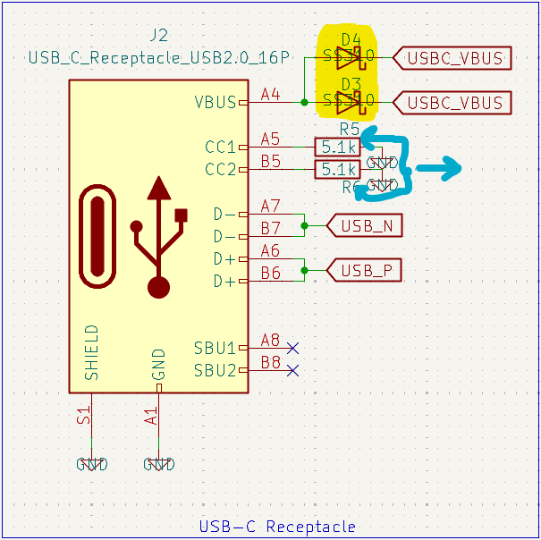
Yellow Highlighter: - SS310 FLYBACK DIODE REMOVED (WHY? Answered below)
Forward voltage drop for SS310 at nominal load 0.5A ~ 0.3v
dynamic resistance Rd = 50 - 100mOhm
Vout = Vin – Vf – I*Rd
ss340
For USB-C 5V : - Nominal = 5v
Minimum allowed at SINK : - 4.75v
USB-C Browns out at 4.6 - 4.7v

When SS310 is added to USB_VBUS entries;
Vin = 5v
Assume: -
Vf = 0.35v
I = 0.8A
Rd = 80mOhm
ΔV = 0.35 + (0.8 * 0.08) = 0.414v
Vout = 5 – 0.414 = 4.586v
USB-C will Brownout even at IDEALISTIC Scenarios + very little margin available for TPS563200 to operate normally.
Realistic values: - Rcable = assume 0.25ohm
ΔVcable = 0.8 * 0.25 = 0.2v
Vin = 5 – 0.2 = 4.8v
Vout = 4.8 - 0.414 = 4.386v
Guaranteed brownout for both TPS563200 and USB-C
Without these diodes, full 5v or 4.8v goes into the Vin pin of the tps563200, which ensures proper functioning, USB-C Power will not be used for RF transmit or receive so the power will not brownout as the load is small.

Blue Arrows: - CC pins (config. Channels) are used for cable orientation detection, role detection and default current advert, for our use case, the device is a SINK, because the PCB has a USB-C Receptacle and we want to receive power through VBUS.
For Sinks, USB-C Requires 5.1kOhm Resistors (Rd) to GND for both CC pins, When this Rd is detected, VBUS is enabled and power supply begins. There are 2 CC pins because USB-C is reversible.
Rp ~ 56kOhm to 5V
Rd ~ 5.1kOhm to GND (SINK)
Vcc = 5v * (5.1k / 56k + 5.1k) ~ 0.42V (Rp and Rd create a Divider)
The Datasheet Indicates that Valid sink is detected when 0.25V – 0.8V is observed
5.1k Lies in the middle of the range and has enough margin on both ends

Current through 5.1k resistors: -
I = V / R; I = 5 / 5100 ~ 0.98mA
Power dissipation: -
P = V^2 / R; P = 25 / 5100 ~ 4.9mW
Standard SMD ratings: -
0402 = 65mW
0603 = 100mW
.
.
.
.
0603 is extremely safe for our requirements.
I have also added ESD protection on the D+ and D- lines for the USB-C interface, its not mandatory, but I felt its better to have it then not have it and try to figure out random board resets which don’t make sense electrically…UCBLC6 is the go-to choice for USB-C ESD protection for Data lines
Trace lengths to the TVS (UCBLC6)
7.02mm for D+
7.26mm for D-
Delta = 0.24mm
Propagation speed on FR-4 ~ 150-170 ps per cm
Timing skew = 0.024cm * 160ps/cm = ~3.84 ps
USB 2.0 Allows for hundreds of picoseconds of skew before major issues, meaning my lengths are around 100 times smaller than anything that matters.
- Barometer: - 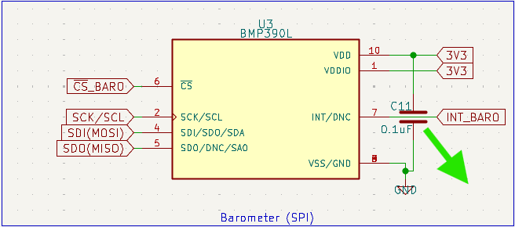
Green arrow: - 0.1uF cap to prevent the barometer from seeing its own switching noise as supply noise,
Without the 0.1uF cap: -assume ΔI = 10mA
Edge time Δt = 2ns
Trace inductance L = 4nH
(A very realistic internal event)
Voltage disturbance = 4 * 10^-9 * 0.01 / (2 * 10^-9) = 20mV
20mV for a pressure sensor is too big

With the 0.1uF cap: - Assuming the same scenario but with a cap now;
ΔV = (0.01 * 2 * 10^-9) / 1 * 10^-7 = 0.2mV
Instead of 20mV, the barometer now only sees 0.2mV (100x reduction in noise)

- Temperature Sensor: -
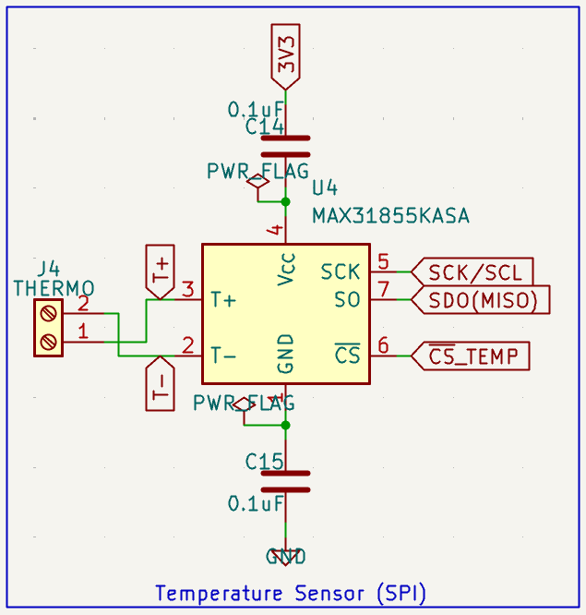
Input decoupling: - 0.1uF cap is used to prevent VCC from dipping during SPI edges, it also reduces jitter, bit errors and internal ADC noise
Output decoupling: - 0.1uF cap added to close the HF return loop and provides a short, low impedance path from VCC GND at the module, it also keeps switching currents local and doesn’t spread all over the board, without it GND bounce increases and SPI noise may couple into thermocouple inputs
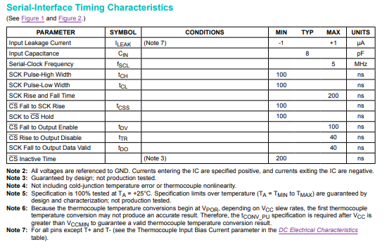
MAX SPI FREQ. = 5MHz
INP. CAPACITANCE = 8pF
Every clock edge must charge/discharge 8pF
Current needed = I = C * (dV/dt)
Assuming C = 8pF
ΔV = 3.3v
Rise time = 100ns (200ns rise and fall time divided by 2 = 100ns)
I = C * (dV/dt)
I = 8 * 10^-12 * (3.3 / (100 * 10^-9))
I ~ 0.264mA

Assuming a generous internal transient current of 1mA

- MOSFETS: - (Chosen MOSFET’s are Infineon BSC026N08NS5) (why? 80V – comfortable margin for 12V systems, Ultra - low RDS (on) = 2.6mOhm at 10V, High SOA (safe operating area) and avalanche rating.)
The MOSFET is used as a low-side power-gating switch and is either fully ON or fully OFF for extended durations. Therefore, losses are dominated by conduction loss rather than switching loss.
Operating Conditions
- Input voltage: 11.1 V nominal (3S Li-Po)
- Topology: Low-side switch
- Gate drive voltage: 10 V (via gate driver)
- Ambient temperature: 40 °C
Conduction Loss
@ 5 A:
P = I²R = 5² × 0.0026 = 0.065 W
@ 10 A:
P = I²R = 10² × 0.0026 = 0.26 W
Accounting for the increase in RDS(on) when MOSFET is hot, worst-case conduction loss will be < 0.4 W.
Thermal Performance
ΔT = P × RθJA = 0.4 × 50 = 20 °C
Tj = 40 + 20 = 60 °C
Well below the maximum junction temperature rating, providing sufficient thermal margin.
Planning to use (UCC27511A-Q1 Single-Channel High-Speed Low-Side Gate Driver With 4A Peak Source and 8A Peak Sink) for the gate driver.

PCB STACKUP Verification: -
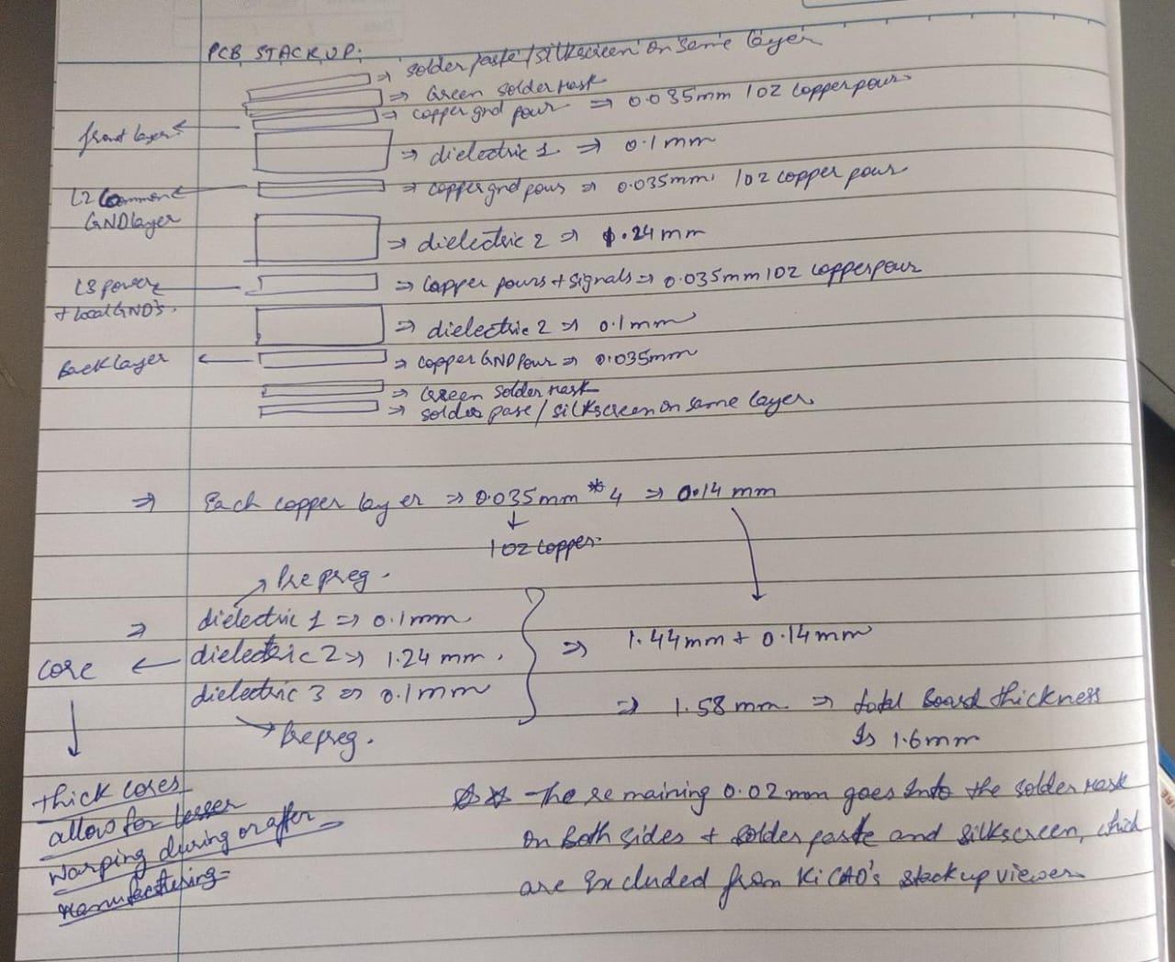
- Used a CP2102N-QFN24 as the usb to uart converter interface (QFN20 is obsolete, and QFN28 isnt required for our applications)

